**Charging the Way Forward:**

**Forecasting EV Growth and Connecting Underserved Areas**

**BAN 693 - Capstone Final Project - Group 1**

**Dr. Chongqi Wu**

*Prepared by:*

Adriel Naranjo (ed2149)

Prabhjot Gilard (ja7207)

Rachel Nguyen (js1642)

Shahnaz Danesh (gu9582)

California State University East Bay

December 8th, 2024

**Table of Contents**

1. Introduction
   1. Objectives
2. Methodology
   1. Data Sources
   2. Analytical Tools and Techniques
   3. Assumptions and Limitations
3. Analysis  
   4.1 Understanding Washington State Population Density  
   4.2 Current EV Population by County in Washington State  
   4.3 Current EV Charging Stations by County in Washington State  
   4.4 Identifying underserved areas using EV population and EV charging stations ratio  
   4.5 Prediction of EV Population Growth in WA  
   4.6 Prediction of Charging Station Growth in WA
4. Discussion
   1. Urban vs. Rural EV Adoption Hypothesis I with respect to expected outcomes
   2. Infrastructure Gaps Hindering Growth Hypothesis II with respect to expected outcomes
   3. Implications of Findings
5. Conclusion
6. Recommendations
   1. Immediate Expansion of Charging Infrastructure in Underserved Areas
   2. Scaling Infrastructure in High-Adoption Counties
   3. State/Federal Incentives for Rural EV Adoption
   4. Data-Driven Planning for Future Growth
   5. Statewide Collaboration for Infrastructure Development
7. Future Work
   1. Seasonal Variations and Extreme Weather Conditions
   2. Socio-Economic Factors Affecting EV Adoption
   3. Collaboration with Climate and Economic Experts
8. References
9. Appendices

**Executive Summary**

This project addresses Washington State’s urgent need for equitable and effective EV charging infrastructure. Unlike previous studies, it comprehensively analyzes EV adoption and charging station accessibility at local levels, identifying urban-rural disparities. The goal is to develop a predictive, scalable solution for optimal station placement, meeting current and future demand while supporting sustainable transportation.

Washington State’s robust EV data, diverse geography, and progressive policies make it an ideal focus. Its urban-rural mix offers a representative model for overcoming infrastructure challenges. Incentives like tax exemptions and clean car standards reinforce the state’s commitment to advancing sustainable transportation.

An additional advantage of this project is its scalability—other states can adapt and apply the predictive models and methodologies developed in this project to their own datasets and EV adoption trends. By doing so, they can make data-informed decisions tailored to their unique needs, ensuring optimal EV charging infrastructure development nationwide.

The methodology involved analyzing EV adoption rates and charging station density using datasets from the Washington State Department of Licensing (DOL) and geographical crosswalk data. Predictive analytics were employed to assess future infrastructure needs based on EV adoption trends.

Key findings reveal that EV adoption is significantly concentrated in urban counties such as Key findings show that EV adoption is heavily centered in urban counties like King and Snohomish, while rural counties struggle with major infrastructure gaps. Urban areas have high EV-to-charging station ratios, indicating the need to quickly expand infrastructure, while low EV adoption in rural regions demands targeted investments and incentives to close the urban-rural divide.

The study concludes that leveraging data-driven planning can optimize resource allocation and infrastructure deployment, avoiding oversupply in well-served areas and underdevelopment in underserved regions. Strategic recommendations include expanding charging networks in rural areas through public-private partnerships, scaling urban infrastructure to accommodate future demand, and implementing statewide predictive analytics to guide infrastructure investments. Additionally, in rural regions, offering incentives for home charging installations can address the lack of readily accessible charging options. To fully realize these benefits, states should integrate data on rural home charging units into their databases, enabling predictive models like ours to incorporate these resources and deliver more precise, equitable infrastructure planning.

1. **Introduction**

As the adoption of electric vehicles (EVs) accelerates in Washington State, the need for an expansive, accessible EV charging infrastructure becomes increasingly critical. The shift towards EVs is driven by environmental goals to reduce greenhouse gas emissions and enhance air quality, aligning with broader state and national sustainability objectives. However, the current EV infrastructure in Washington has yet to fully meet the growing demand. Without strategic development, gaps in charging availability could hinder continued EV adoption, particularly in areas with high population density or significant commuter traffic.

Recent federal investments through the Bipartisan Infrastructure Law, such as the Charging and Fueling Infrastructure (CFI) Discretionary Grant Program and the National Electric Vehicle Infrastructure (NEVI) Formula Program, are expediting the expansion of EV charging networks nationwide. These programs have led to over 192,000 public charging ports nationwide, with around 1,000 new chargers added weekly. This includes community-focused projects, like a new DC Fast Charging station on the University of Washington Bothell campus, which will serve disadvantaged areas.

This project addresses Washington’s infrastructure needs by leveraging data from the Washington State Department of Licensing (DOL) EV dataset, along with geographic and demographic information, to assess and forecast demand for EV charging stations. The analysis identifies key areas for charging station development, supporting the state’s sustainable transportation goals. Moreover, the insights gained from this project can inform other states aiming to scale their EV infrastructure in alignment with increasing EV ownership and environmental goals.

**Objective:** To develop a predictive, data-driven solution for optimizing EV charging station placement in Washington State, addressing urban-rural disparities and ensuring equitable, efficient infrastructure to meet current and future demand.

The main objective of this project is to address the growing demand for Electric Vehicle (EV) charging infrastructure in Washington State by developing a predictive, data-driven solution that identifies optimal locations for future EV charging stations. The insights gained from this project can inform other states aiming to scale their EV infrastructure in alignment with increasing EV ownership and environmental goals.This report is to assess the current state of electric vehicle (EV) adoption and infrastructure (charging stations) in Washington State, identify regions with underserved infrastructure, and provide actionable recommendations for equitable and efficient infrastructure development. The aim is to ensure that EV infrastructure meets current and future demand across all regions of the state, especially in rural and underserved areas.This predictive approach ensures development that aligns with anticipated EV adoption, preventing accessibility gaps and supporting Washington’s transition to sustainable transportation.

To achieve this objective, the project required the following steps:

1. **Build an End-to-End ETL Pipeline:** A comprehensive ETL (Extract, Transform, Load) pipeline will be constructed to process data from the Washington State Department of Licensing (DOL) EV dataset and a Zip Code to County FIPS Crosswalk dataset. Using Apache Airflow for orchestration and PySpark for data transformation on Google Cloud Platform (GCP), this pipeline will ensure that the data is clean, integrated, and ready for analysis.
2. **Develop a Tableau Dashboard for Strategic Planning:** A Tableau dashboard connected to Google BigQuery will provide interactive, visual insights into EV ownership patterns and infrastructure demand. This dashboard, featuring tabular and geographic data visualizations, will allow state authorities, urban planners, and infrastructure agencies to make informed, data-driven decisions about EV infrastructure.
3. **Identify geographical areas for New Charging Stations:** Using detailed insights from geographical maps and ownership patterns across Washington State, the project will recommend targeted areas for new charging stations. This granular analysis, conducted down to the county level, aims to close infrastructure gaps and ensure that EV owners have convenient access to charging facilities as the adoption of electric vehicles continues to grow.
4. **Deliver a Reusable and Scalable Solution:** This project will produce a low-cost, adaptable solution that other states can leverage. By ensuring scalability, the ETL pipeline and dashboard can accommodate future data sources and increased data volume, supporting the growth of EV infrastructure nationwide.

Ultimately, this project aims to support Washington State’s environmental goals and foster sustainable EV adoption, contributing to a national strategy for robust EV infrastructure expansion.

**II. Methodology**

This project focused on multiple electric vehicle (EV) datasets, encompassing vehicle history, infrastructure details like power plants, and EV charging stations, all specific to Washington State. This initiative aimed to strengthen business intelligence for strategic EV infrastructure planning by leveraging Apache Airflow, Google Cloud Platform (GCP), and Tableau to build a comprehensive data framework covering the full lifecycle from collection to insights.

1. **Data Sources:**We gathered data from various authoritative sources, including state and federal databases accessible via APIs, ensuring real-time, reliable information. Automated workflows orchestrated by Apache Airflow were set up to systematically pull data into Google Cloud Storage (GCS), where secure authentication protocols managed data access and storage.
2. **Analytical Tools and Techniques:**Data processing relied on Google Cloud Dataproc, where we executed PySpark scripts to cleanse, transform, and structure raw data for consistency and readiness. Once prepared, data was loaded into Google BigQuery, our choice for data warehousing, allowing for complex analyses. Finally, we used Tableau for visualization and dashboarding, enabling stakeholders to gain actionable insights for data-driven EV infrastructure planning.
3. **Assumptions and Limitations:**In our analysis, we assumed the accuracy and completeness of state and federal datasets, with some data gaps addressed by imputing certain values. Limitations included potential latency in real-time updates and the reliance on external databases for consistent information, which may impact the analysis.

Overall, this project highlights handling large-scale datasets with industry-aligned practices, emphasizing security, scalability, and analytical rigor to drive actionable insights for infrastructure development.

1. **Hypothesis 1:** Urban areas in Washington State have a significantly higher EV population per charging station compared to rural areas.
2. **Hypothesis 2:** The growth rate of EV populations in Washington State can be accurately predicted based on the projected expansion of charging station networks, with a direct correlation between the two

**III. Analysis**

**3.1 Understanding Washington State Population Density**

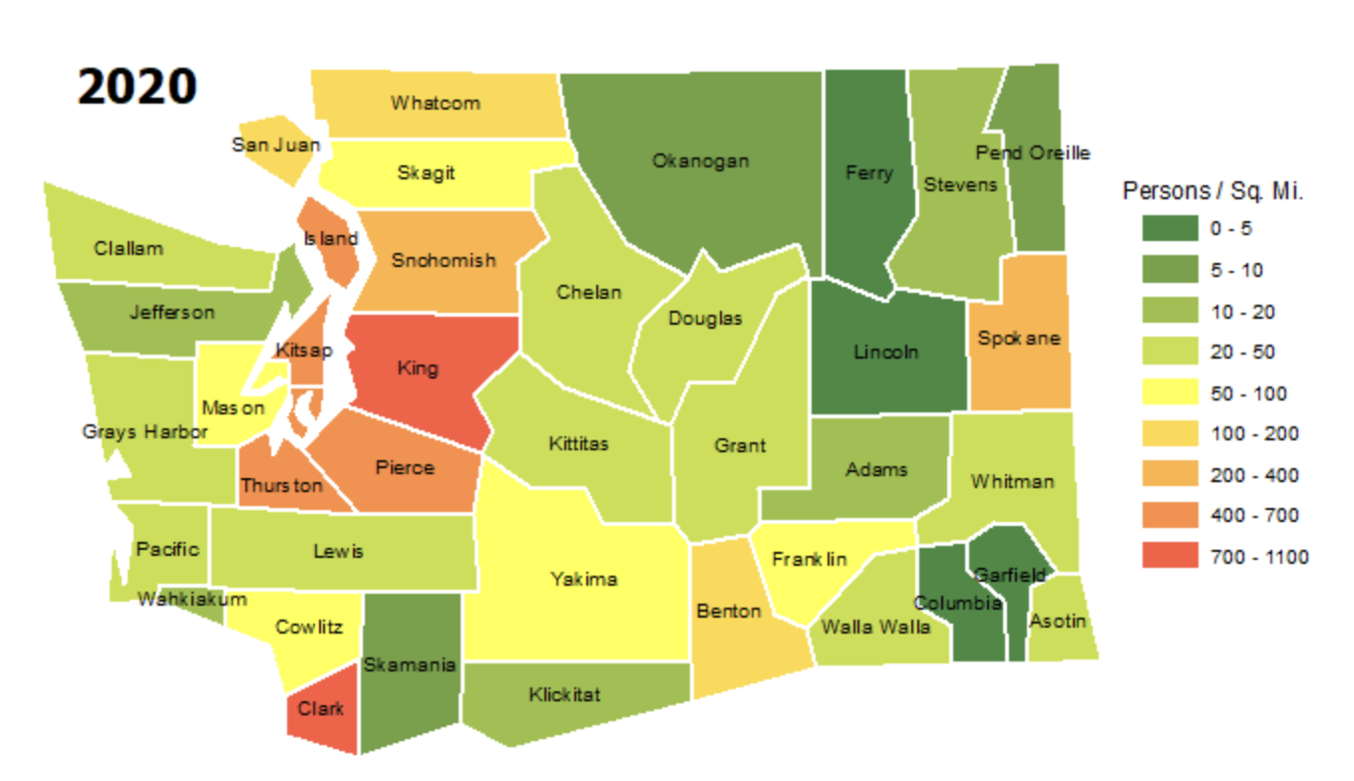

**Figure:** Population Density by County in Washington State, 2020 (Office of Financial Management)

Washington State's population density and its relationship to urbanization and tech hub growth offer valuable insights into the state's development patterns. Based on the 2020 census data by Washington State Office of Financial Management, population trends highlight significant contrasts between urban and rural areas. *King County*, the state's most populous region, stands out with its dense urban centers such as Seattle, Bellevue, and Redmond. Seattle alone, with over 800,000 residents, exemplifies the high-density living characteristic of a major metropolitan area. Neighboring counties, including *Pierce* and *Snohomish*, contribute to the region's density through cities like Tacoma and Everett. In southwestern Washington, *Clark* County has seen significant suburban growth, influenced by its proximity to the Portland, Oregon metropolitan area. In contrast, rural counties such as *Garfield, Columbia*, and *Ferry* in Eastern Washington maintain low population densities due to their agricultural focus and expansive natural landscapes. Coastal counties like *Wahkiakum* similarly reflect a rural character, with sparse populations spread across smaller communities.

The *Puget Sound* region, as the epicenter of Washington's tech industry, is a major driver of population growth. Cities such as Seattle and Bellevue are home to global tech giants like Amazon and Microsoft, drawing a diverse workforce and increasing demand for housing and infrastructure. Redmond, known as Microsoft's headquarters, has experienced remarkable economic and population growth. This tech-driven expansion also extends to surrounding cities like Kirkland, Issaquah, and Bothell, where rising residential densities reflect spillover effects from the central hubs. Urban counties continue to attract new residents due to abundant job opportunities in technology and service sectors. However, rural areas face challenges such as population stagnation or decline. The rising densities in urban areas necessitate infrastructure development, including expanded transit systems, housing, and public services, to accommodate the growing demand.

The correlation between tech hub development and population growth underscores the state's evolving dynamics. While urban areas thrive with high-paying tech jobs and rapid development, rural regions lag behind, highlighting a need for balanced growth strategies. Policymakers are increasingly addressing these disparities to ensure sustainable development across Washington.

**3.2 Current EV Population by County in Washington State**

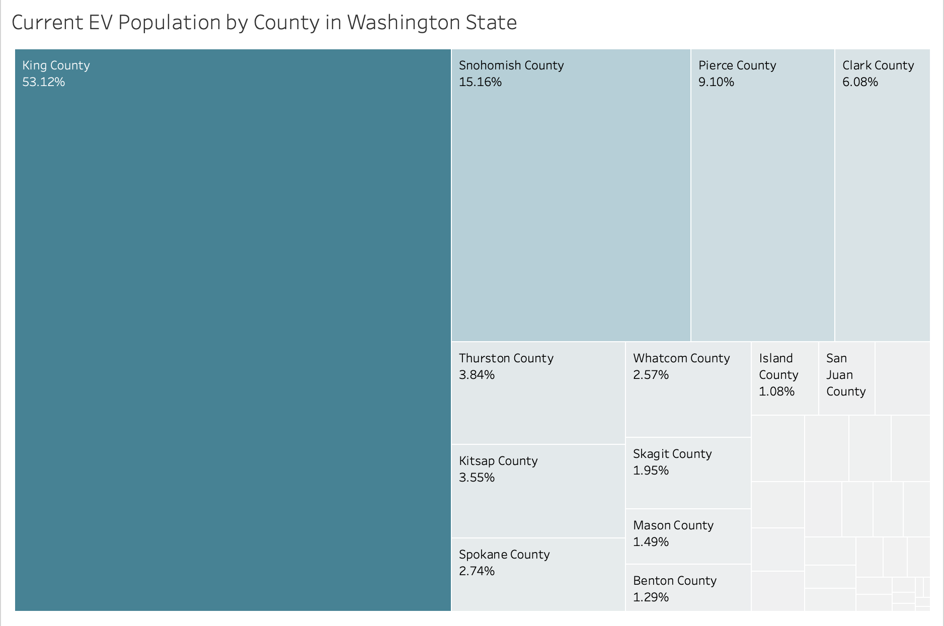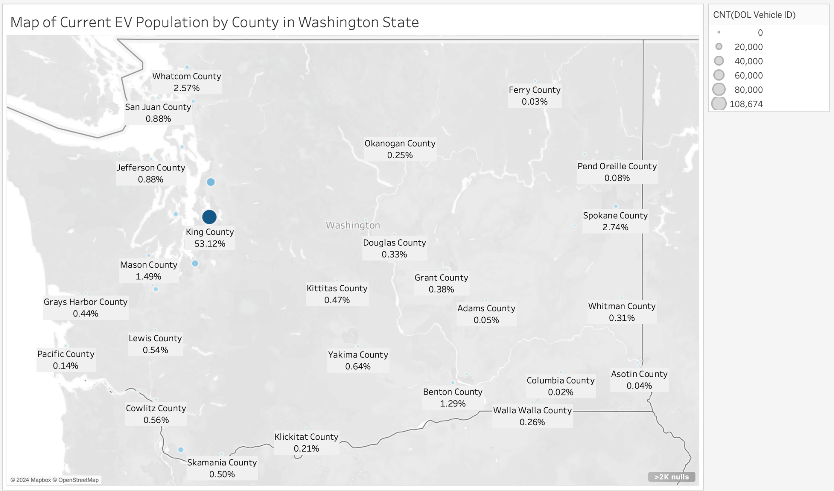

The geographical map and treemap illustrate the distribution of electric vehicle (EV) populations by county in Washington State, with King County leading by a significant margin, accounting for 53.12% of the total EV population. This dominance reflects King County's status as a densely populated and urbanized area, likely supported by better infrastructure for EVs, such as charging stations and incentives. Snohomish County follows at 15.16%, and Pierce County contributes 9.10%, together comprising a significant portion of the state's EV population. These counties are also part of the greater Seattle metropolitan area, indicating that urban centers play a critical role in EV adoption.

Other counties, such as Clark County (6.08%), Thurston County (3.84%), and Kitsap County (3.55%), show moderate adoption rates. Spokane County, the largest city in eastern Washington, accounts for 2.74%, highlighting EV adoption even outside the western urban areas. Smaller counties, such as Whatcom County (2.57%), Skagit County (1.95%), and Mason County (1.49%), represent the remainder of the distribution, indicating lower adoption rates likely due to smaller populations or limited infrastructure.

Overall, the chart highlights a strong correlation between urban density and EV adoption, with King County serving as the clear leader in Washington State. The map also highlights the disparity in EV adoption across Washington State. High-adoption areas like King County may benefit from continued infrastructure expansion to support growing EV numbers, while rural counties may require incentives to stimulate EV adoption before investing heavily in charging stations.

**3.3 Current EV Charging Stations by County in Washington State**

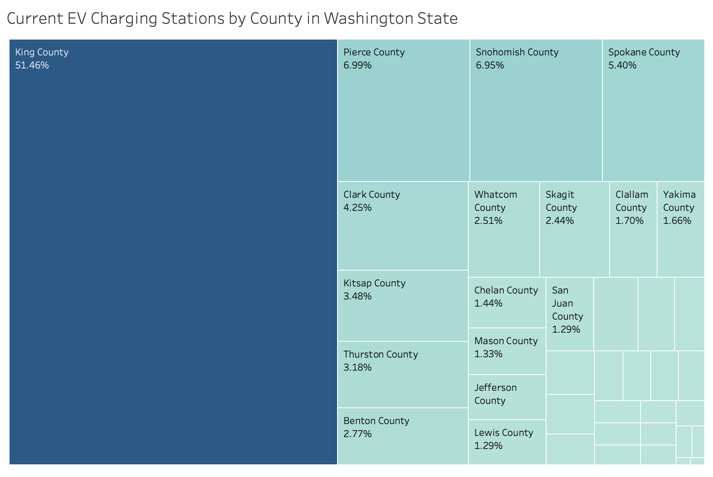The treemap chart displays the distribution of electric vehicle (EV) charging stations by county in Washington State. King County stands out as the dominant location for EV charging infrastructure, holding 51.46% of all charging stations. This is significantly higher than any other county, highlighting King County’s central role in supporting EV accessibility in the state. Following King County, Pierce County (6.99%) and Snohomish County (6.95%) also contribute a notable share but are much lower in comparison. Spokane County (5.40%) and Clark County (4.25%) are other sizable contributors.

Counties like Kitsap (3.48%), Thurston (3.18%), and Benton (2.77%) have moderate shares, while smaller counties such as Whatcom (2.51%), Skagit (2.44%), and Clallam (1.70%) have relatively fewer stations. The least represented counties include San Juan, Lewis, Jefferson, and others, each making up under 1.5% of the state’s total. This distribution indicates a concentration of charging stations in more urbanized or densely populated areas, particularly in and around Seattle, which is located in King County, with a steep drop-off in rural or less populated counties. This trend may reflect higher EV adoption rates and infrastructure investments in urban areas compared to rural regions.

**3.4 Identifying underserved areas using EV population and EV charging stations ratio**

To estimate the average number of outlets per EV charging station for our Tableau calculations, we’ve settled on using five outlets per station. This estimate stems from analyzing patterns in different types of charging locations and approximating based on available data. Generally, corporate or private stations, such as those at office buildings, tend to have fewer outlets—typically around two—since they cater to employees or specific user groups with lower traffic. In contrast, public stations, such as those at malls, parking garages, or high-traffic areas like highways, generally require more outlets to meet higher demand, often ranging between four and eight outlets. Public charging providers, like ChargePoint and Tesla, often set up stations with multiple outlets to accommodate the volume of EVs needing quick access to charging facilities.

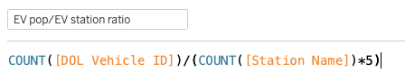

Without precise data on the charging speeds (Level 1, Level 2, or DC Fast Charging) or the outlet count for each station, using a rough average based on location type and industry insights—settling on five outlets—gives us a workable approach to approximate infrastructure in various settings. This estimation aligns with findings from the U.S. Department of Transportation, which highlights that public charging stations generally have higher outlet counts due to increased demand for faster and more accessible EV charging.

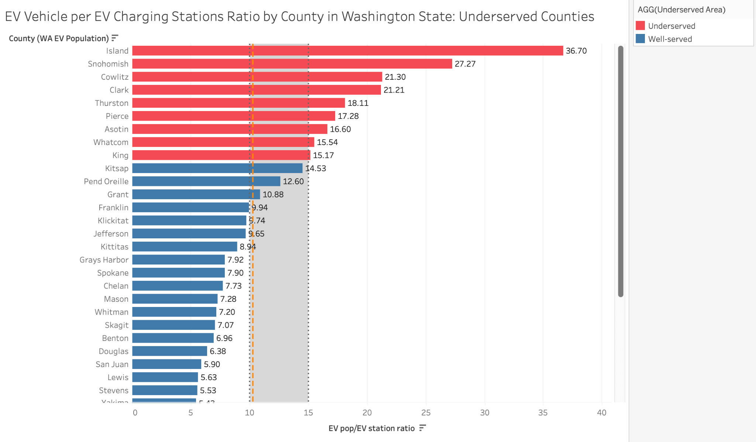

This chart illustrates the ratio of electric vehicles (EVs) per charging station across various counties in Washington State, with a focus on identifying underserved counties. The orange line represents the state average ratio, which is about 10.27 EVs per charging station, while the shaded area marks the suggested range of 10 to 15 EVs per charging station. Counties that fall outside this range, particularly those above it, are considered underserved.

Island County has the highest EV-to-charging-station ratio at 36.7, indicating a significant shortage of charging infrastructure relative to EV usage. Other counties with high ratios include Snohomish (27.27), Cowlitz (21.30), and Clark (21.21), all of which are marked in red, indicating underserved areas. These counties exceed the suggested ratio, highlighting the need for additional charging stations to meet the demand.

Several counties, including Pend Oreille (12.60), Grant (10.88), and Franklin (9.94), have ratios closer to the state average or within the suggested range, indicating a more balanced supply of charging stations. Counties in the shaded area, marked in blue, such as Klickitat (9.74), Jefferson (9.65), and Kittitas (8.94), are classified as well-served, with an adequate number of charging stations for the current EV population.

At the lower end of the ratio spectrum, Lewis County has the lowest ratio (5.63), suggesting it has more charging stations than needed for the current number of EVs. Overall, the chart reveals a disparity in EV infrastructure, with certain counties significantly underserved and others better aligned with recommended levels of infrastructure.

The following charts examine the ratio of electric vehicles (EVs) to EV charging stations in various cities within Island County, Snohomish County, and King County, Washington State, focusing on identifying underserved areas.

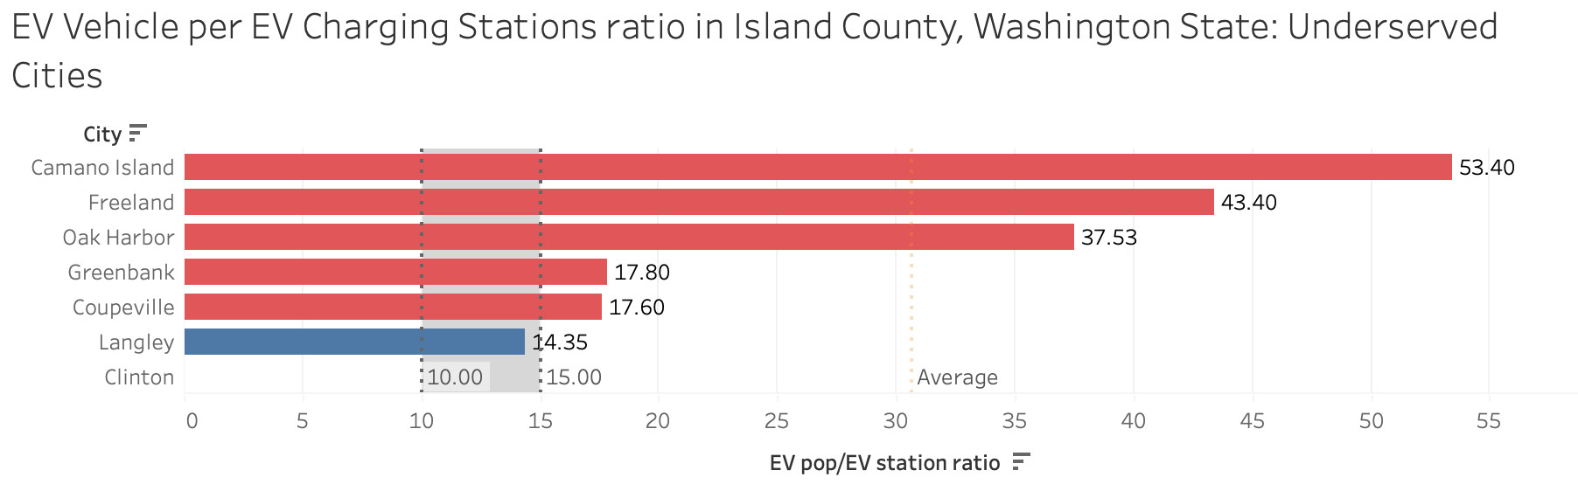

In Island County, Camano Island city has the highest ratio at 53.4, signaling a considerable shortage of charging infrastructure relative to EV demand. Clinton (43.4), Coupeville (17.6), Freeland (17.8), and Greenbank (17.8) also exceed the recommended range, making them underserved and in need of more charging stations to support the current EV population. Langley, with a ratio of 14.35, is the only city within the suggested range, indicating a well-balanced supply of EV charging stations. The chart reveals that most cities in Island County are underserved, with EV-to-charging-station ratios well above the ideal range. This suggests that Island County requires a significant increase in charging infrastructure to meet the needs of its EV population, especially in highly underserved areas like Camano Island and Clinto

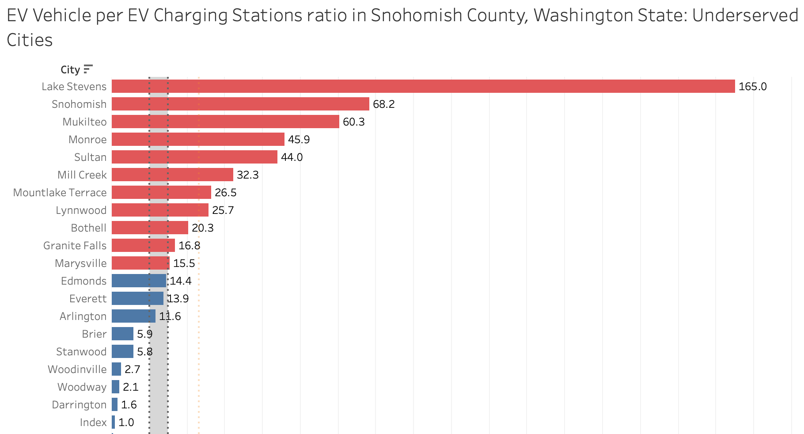

In Snohomish County, the city of Lake Stevens has the highest EV-to-charging-station ratio at 165, highlighting a significant shortage of charging infrastructure to meet EV demand. Other cities, including Snohomish (68.2), Mukilteo (60.3), Monroe (45.9), Sultan (44.0), Mill Creek (32.3), Lynnwood (25.7), and Granite Falls (16.8), also exceed the recommended ratio range, indicating they are underserved and in need of more charging stations to support their EV populations. Conversely, cities such as Edmonds, Arlington, Brier, and Stanwood, with ratios below 15, fall within the recommended range, suggesting a more balanced supply of charging infrastructure. Overall, the data reveals that most cities in Snohomish County are underserved, with EV-to-charging-station ratios significantly above the ideal range. This underscores the need for a substantial expansion of charging infrastructure, particularly in highly underserved areas like Lake Stevens and Snohomish.

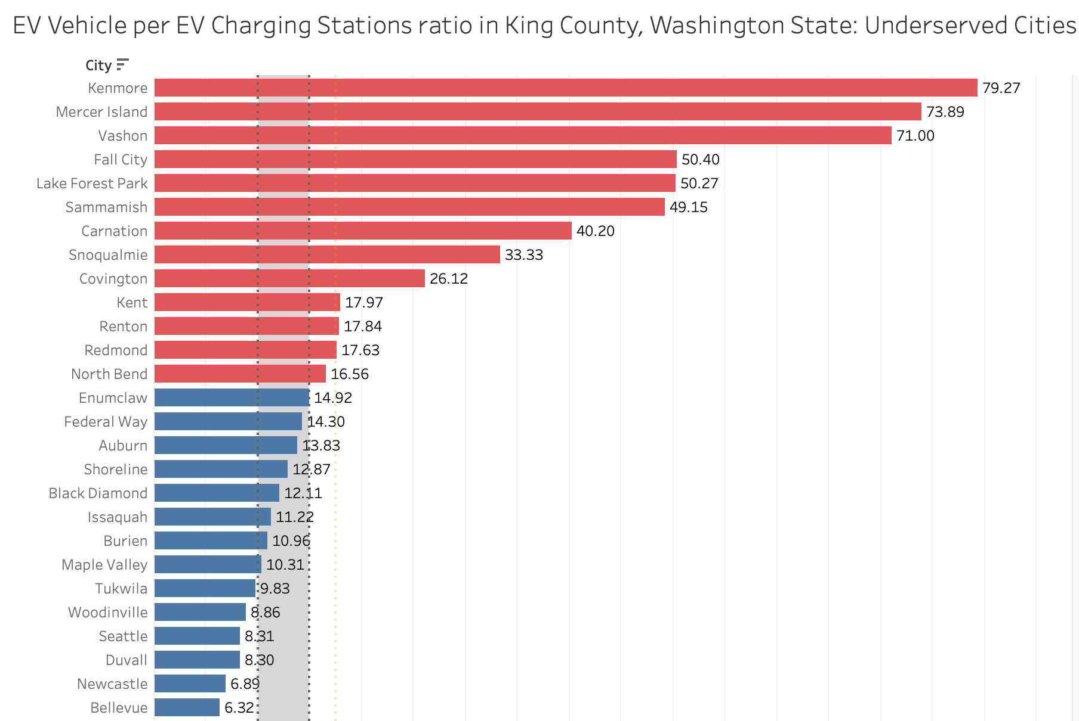

In King County, the city of Kenmore has the highest EV-to-charging-station ratio at 79.27, indicating a significant shortage of charging infrastructure to meet the rising demand from EV owners. Other cities, such as Mercer Island (73.89), Vashon (71.00), and Fall City (50.40), also exhibit high ratios, suggesting that they are underserved and require a more substantial investment in EV charging stations to accommodate their growing EV populations. Cities like Sammamish (49.15), Carnation (40.20), and Snoqualmie (33.33) also exceed the recommended range, further highlighting the infrastructure gaps across the county. In contrast, cities such as Duvall (8.30), Seattle (8.31), and Tukwila (9.83) demonstrate more balanced ratios, falling well within the recommended range for EV charging infrastructure. This suggests that these areas have a relatively sufficient supply of charging stations to support their EV populations. Overall, the data reveals that many cities in King County are underserved, with ratios significantly above the ideal range.

**3.5 Prediction of EV Population Growth in Washington State**

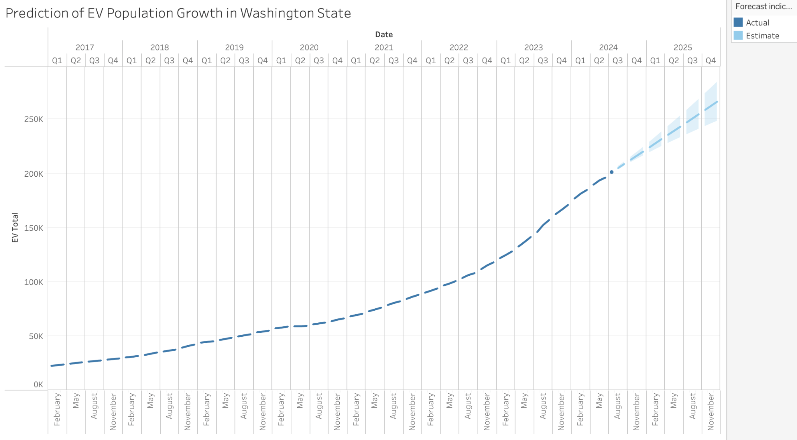

This graph illustrates the prediction of the electric vehicle (EV) population in Washington State from 2017 to 2025. The y-axis represents the total number of EVs, while the x-axis displays time in quarters. The prediction currently uses data from January 2017 to July 2024 to create a seasonality forecast through December 2025. The actual EV population data is shown up to the present, with a dashed line extending into the future to represent estimated growth. Exponential smoothing method is being employed in the model with 95% prediction intervals.

From 2017 to 2023, the EV population shows a steady increase, indicating consistent adoption over time. The growth rate appears to accelerate notably after 2020, potentially reflecting policy changes, technological advancements, or increasing consumer interest in EVs. Projections for 2024 and 2025 show a continuation of this upward trend, with *1.5% to 6% growth* and confidence intervals (shaded bands) indicating a degree of uncertainty in the forecast.

The graph suggests a strong and sustained growth in EV adoption in Washington State, reflecting both increasing environmental consciousness and supportive infrastructure or incentives. By 2025, the EV population is estimated to surpass 250,000, highlighting significant progress toward greener transportation.

**3.6 Prediction of Charging Station Growth in Washington State**

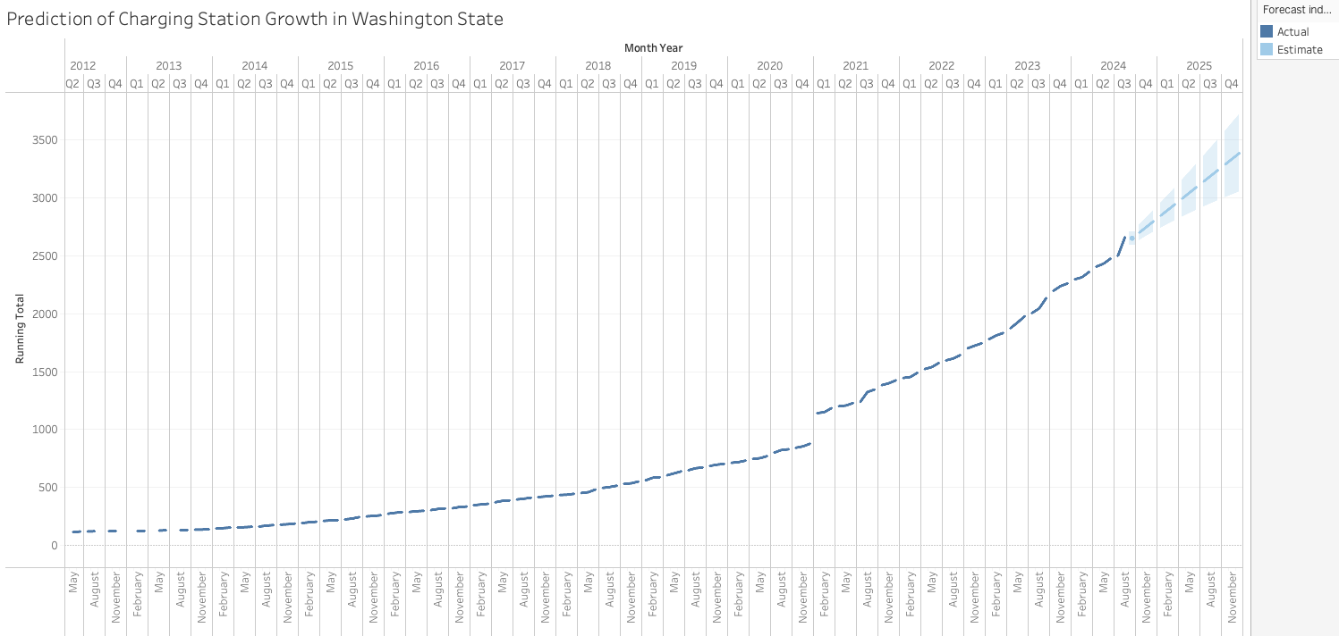

This graph depicts the predicted growth of charging stations in Washington State from 2010 to 2025. The prediction currently uses data from July 2010 to August 2024 to create a seasonality forecast through December 2025. The y-axis represents the running total of charging stations, while the x-axis marks the time in quarters. The actual data is represented up to the present, followed by a forecast with confidence intervals shown for 2024 and 2025. Exponential smoothing method is being employed in the model with 95% prediction intervals.

From 2010 to 2023, the data reflects steady growth in the number of charging stations, with a noticeable acceleration starting around 2019. This upward trajectory likely aligns with increased adoption of electric vehicles (EVs), reflecting a growing demand for charging infrastructure. The projections for 2024 and 2025 indicate a continued *3% to 8% increase*, reaching a total of over 3,500 charging stations by the end of 2025. The forecast suggests confidence in the trend, with only a modest range of uncertainty.

This chart emphasizes the state’s commitment to expanding its EV infrastructure, ensuring accessibility and convenience for a rapidly growing EV population. It highlights an alignment between infrastructure development and EV adoption, crucial for supporting the transition to sustainable transportation.

**IV. Discussion**

**Urban vs. Rural EV Adoption Hypothesis I with respect to expected outcomes:**According to our analysis the EV adoption is disproportionately concentrated in urban areas versus the rural counties (especially those in Eastern Washington), which shows lower adoption rates.The findings henceforth confirms this hypothesis to be true, as the data shows high EV adoption in counties like King and Snohomish but much lower adoption in rural counties such as Ferry and Asotin.

**Infrastructure Gaps Hindering Growth Hypothesis II with respect to expected outcomes:**In the hypothesis for infrastructural gaps hindering the growth we found the current imbalance in EV-to-charging station ratios suggests that underserved regions will struggle to meet future EV demand unless infrastructure development is prioritized.With respect to the outcome based on our findings this is evident in counties such as Grays Harbor and Skamania, where the high EV-to-charging station ratios indicate a need for more charging stations to keep up with the increasing EV population.

**IMPLICATIONS OF FINDINGS**

### **1) Imbalance Between Urban and Rural EV Adoption:**

The findings reveal a disproportionate concentration of EVs in urban areas like King and Snohomish counties, with rural areas such as Ferry, Skamania, and Grays Harbor showing lower adoption rates. This urban-rural divide has broad implications for infrastructure planning and state policy. Without intervention, rural areas may continue to face challenges in adopting electric vehicles due to the limited availability of charging stations.

If this imbalance is not addressed, rural regions may be left behind in the state's transition to clean energy and may miss out on economic opportunities tied to the EV market. Moreover, rural drivers may experience "range anxiety" due to insufficient charging stations, preventing them from adopting EVs. This could hinder the state’s overall environmental and sustainability goals, slowing the reduction of greenhouse gas emissions.

### **2) Infrastructure Gaps and EV-to-Charging Station Ratios:**

The findings on EV-to-charging station ratios highlight the mismatch between the number of EVs in certain cities and the availability of charging infrastructure. Cities such as Lake Stevens and Startup in Snohomish County show extremely high EV-to-charging station ratios, indicating an urgent need for additional infrastructure.

These infrastructure gaps could deter potential EV owners in underserved cities, impacting EV adoption rates. Without sufficient charging stations, EV users in these areas may not have reliable access to charging, limiting the overall adoption of electric vehicles. Additionally, the state's ability to meet its long-term sustainability goals could be compromised if infrastructure development is not accelerated in these high-demand regions.

### **3) Urban Areas Needing Proactive Infrastructure Scaling:**

In urban counties like King and Pierce, there is a growing number of EVs. The need for proactive scaling of infrastructure is vital to ensure that these urban areas can accommodate the increasing demand for EV charging. The findings suggest that while infrastructure is currently adequate, it will soon need to be upgraded and expanded. Charging station builders need to stay updated with the guidelines and regulations of building charging infrastructure with current and incoming technologies. This is different from the previous finding as it addresses continuously growing areas rather than areas with an excessive EV impingement.

If infrastructure in these areas is not expanded in a timely manner, urban EV owners could face challenges in finding available charging stations, potentially leading to dissatisfaction and deterring further EV adoption. Moreover, scaling up infrastructure in high-demand areas like Seattle will create a positive feedback loop, encouraging further adoption and reinforcing the state's commitment to clean energy.

### **4) Need for Targeted Incentives and Policy Interventions in Rural Areas:**

The findings underscore the importance of implementing policies and financial incentives targeted at rural areas to increase EV adoption. Rural counties have not only low EV adoption rates but also limited access to charging infrastructure. Incentives like tax rebates, financial subsidies, and grants for infrastructure development can play a crucial role in addressing this gap.

Without financial support and targeted incentives, rural areas may continue to lag behind urban areas in EV adoption, which would exacerbate the urban-rural divide in clean energy transition efforts. By implementing supportive policies, the state can stimulate demand for EVs in rural regions, reduce greenhouse gas emissions, and promote environmental equity.

**5) Environmental and Economic Implications for Washington State:**

The expansion of EV infrastructure across the state, particularly in underserved areas, is essential for achieving the state's environmental goals. As EV adoption rises, reducing the state's reliance on fossil fuels and lowering transportation-related emissions is crucial for meeting carbon reduction targets. Additionally, the growth of the EV market can create economic opportunities, such as job creation in the green energy sector and the development of new businesses in EV infrastructure.

The state's ability to meet its climate change targets depends on the successful expansion of EV infrastructure. Uneven infrastructure development could undermine the state's overall efforts to reduce its carbon footprint, especially if rural areas do not adopt EVs at the same rate as urban centers. On the economic front, expanding EV infrastructure across the state could spur job growth, particularly in construction, manufacturing, and clean energy sectors, contributing to the state's economy.

### **6) Social and Equity Implications:**

The geographic and economic disparity in EV adoption and infrastructure availability has significant implications for social equity. If certain communities (especially rural, low-income, and disadvantaged communities) do not have adequate access to EV charging infrastructure, they will be left out of the benefits of the clean energy transition. This disparity could further exacerbate inequalities in access to green technologies.

An unequal distribution of EV infrastructure could deepen the social and economic divide between urban and rural residents. Ensuring equitable access to EV charging stations in all regions of Washington State will be key to creating a fair transition to a low-carbon economy. Addressing these equity concerns will help prevent marginalized communities from being left behind in the shift to electric transportation.

### **7) Strategic Role of Data-Driven Decision Making:**

The findings emphasize the importance of leveraging data to plan for future EV infrastructure needs. Predictive analytics can help identify areas with potential for high EV adoption, enabling more informed and effective planning. Data-driven decision-making allows for a more targeted and strategic approach to infrastructure deployment, reducing the risk of underdevelopment or oversupply.

By using data to guide infrastructure investment, Washington State can avoid misallocating resources and ensure that charging stations are deployed in the most strategic locations. This will ensure that infrastructure development keeps pace with the growing demand for EVs, leading to more efficient and cost-effective outcomes.

### **Overall Significance and Potential Long-Term Impact:**

The findings of this report have far-reaching implications for Washington State’s electric vehicle adoption, infrastructure planning, and broader environmental policies. Addressing the infrastructure gaps in rural areas and scaling up in urban regions will be essential for achieving statewide goals of reducing carbon emissions and transitioning to clean energy. The report's recommendations suggest actionable steps that can be taken immediately to ensure a sustainable and equitable EV infrastructure network.

By acting on these insights, Washington State can not only enhance its environmental sustainability but also support economic growth, social equity, and the transition to a greener future. The expansion of EV infrastructure will stimulate job creation, encourage innovation, and help make clean energy accessible to all regions of the state, ensuring that no community is left behind in the shift toward electric transportation.

**V. Conclusion**

**1) Unequal EV Adoption Across Washington State:** The findings confirm that EV adoption is concentrated in urban areas such as King County, while rural areas (especially in Eastern Washington) are lagging in terms of adoption and infrastructure. This unequal distribution highlights the need for tailored strategies to address infrastructure gaps.

**2) Infrastructure Gaps in Underserved Regions**: The significant disparity in the EV-to-charging station ratios across counties and cities in Washington State highlights the need for urgent infrastructure development in underserved regions. These regions (Grays Harbor, Skamania, Lake Stevens, Startup) require immediate intervention to avoid stalling the state's EV growth.

**3) Proactive Infrastructure Scaling and Expansion:** Well-served counties like King and Pierce must proactively scale their infrastructure to match the expected increase in EV ownership. In contrast, rural counties need targeted incentives and support to both stimulate EV adoption and build out their charging networks.

**VI. Recommendations**

1. **Immediate Expansion of Charging Infrastructure in Underserved Areas:**

Priority should be given to counties with high EV-to-charging station ratios, such as Grays Harbor, Skamania, and Ferry, as well as cities within Snohomish County like Lake Stevens and Startup. These areas urgently need an expansion of charging infrastructure to accommodate the growing demand for EVs. Collaborating through public-private partnerships including private companies, local businesses, and government agencies can accelerate the deployment of charging stations in underserved regions. Additionally, businesses should be encouraged to install workplace chargers, especially in rural areas where public charging options are scarce.

**2) Scaling Infrastructure in High-Adoption Counties:**

Counties like King, Pierce, and Snohomish, which currently have well-developed EV adoption rates, must take proactive measures to expand and enhance their charging infrastructure to meet the increasing demand. As the number of EV owners continues to grow, these regions need to focus on upgrading existing charging stations to improve efficiency and reliability. Additionally, installing high-speed chargers in strategic locations will accommodate the needs of drivers who require faster charging options during their commutes or long-distance travel.

To ensure long-term sustainability, implementing scalable infrastructure is essential. Modular charging stations, which can be expanded as demand increases, provide a flexible solution that avoids overbuilding or underutilization. Furthermore, expanding centralized charging hubs in high-traffic areas will enhance accessibility and reduce wait times for EV users. By taking these steps, these counties can not only support the current growth in EV ownership but also future-proof their infrastructure to align with adoption trends in the years to come.

**3) State/Federal Incentives for Rural EV Adoption:**

To encourage EV adoption in rural areas with historically low uptake, a comprehensive approach blending financial incentives and infrastructure development is essential. Offering tailored financial incentives—such as rebates, tax breaks, or grants—can reduce the upfront cost of purchasing an EV, making it more accessible to rural residents. Additionally, providing incentives specifically for home charging installations in rural households will foster a more convenient and reliable charging ecosystem in these underserved regions.

Simultaneously, states should incorporate data on these rural home charging units into their databases, enabling predictive models like ours to account for this expanded infrastructure. Expanding the public charging network in underserved rural areas is equally critical. By addressing “charging deserts” and improving affordability and accessibility, a sustainable cycle of increased EV adoption and greater infrastructure investment can be established, benefiting rural communities in the long term.

**4) Data-Driven Planning for Future Growth:**

Leveraging predictive analytics is a crucial strategy for effective infrastructure planning to support the growth of electric vehicle (EV) adoption. By using data-driven models, it is possible to forecast future EV adoption rates across both urban and rural regions. These insights enable planners to anticipate where the demand for EV charging infrastructure will grow, ensuring that development efforts are both timely and strategically aligned with future needs.

Predictive analytics helps to avoid scenarios where some areas face underdeveloped charging networks, leading to accessibility challenges for EV users, while others may end up with an oversaturation of charging stations, resulting in underutilized resources. By analyzing factors such as population density, current EV ownership trends, income levels, travel patterns, and charging station usage, these models can identify specific regions where infrastructure upgrades or expansions are most needed.

This approach not only supports efficient allocation of resources but also ensures equitable access to charging infrastructure, particularly in areas where EV adoption is expected to rise significantly. Furthermore, it allows policymakers and stakeholders to make informed decisions, balancing short-term needs with long-term goals to build a robust and sustainable EV charging network.

**5) Statewide Collaboration for Infrastructure Development:**

To ensure a fair and effective distribution of EV charging infrastructure across the state, it is essential to foster coordination between urban and rural areas. This approach will help bridge the gap in accessibility and ensure that no region is left behind in the transition to electric vehicles. A well-balanced distribution of charging stations will support both high-demand urban areas and underserved rural communities, creating a more inclusive network for EV users.

Achieving this requires collaboration among a diverse group of stakeholders, including municipalities, local governments, utility providers, and private sector partners. Urban areas can share best practices and resources to help rural regions establish foundational infrastructure, while rural areas can identify specific challenges unique to their geography and demographics. Coordination can also include creating shared funding initiatives or joint planning efforts to streamline infrastructure development and avoid duplication of efforts.

By working together, stakeholders can design a comprehensive, statewide EV charging network that meets the needs of all communities. This collaborative approach will not only improve accessibility but also strengthen the long-term sustainability of the EV infrastructure, ensuring it evolves in tandem with the growing demand for electric vehicles.

**Future Work**The project has revealed several important research areas that could significantly enhance the planning and development of EV infrastructure. One of the key areas for further investigation is the impact of seasonal variations and extreme weather conditions on electric vehicle usage and charging demands. Understanding how factors like temperature, humidity, and seasonal weather patterns affect EV performance can provide valuable insights into how infrastructure needs to be adapted. For instance, colder climates can reduce the efficiency of EV batteries, making it necessary to have a higher density of charging stations in regions with harsher winters. This would help mitigate issues related to longer charging times or reduced range during colder months. In contrast, warmer climates may exhibit different energy demands due to changes in travel patterns and charging behavior, suggesting that charging infrastructure should be tailored to these regional differences.

Another area of potential research involves socio-economic factors that influence EV adoption rates. Factors such as household income, geographic location (urban vs. rural), and access to public transit could reveal distinct patterns of EV adoption across different communities. For example, wealthier neighborhoods may have higher rates of EV adoption due to greater financial resources for purchasing vehicles, while rural areas may struggle with EV accessibility due to insufficient charging infrastructure and longer travel distances. Exploring these socio-economic factors could help identify the barriers to EV adoption in underserved communities and inform strategies to overcome them, such as targeted incentives or infrastructure development.

Additionally, climate factors play a crucial role in determining EV usage, and expertise from meteorologists could be instrumental in analyzing how weather conditions affect battery performance and charging behaviors. For instance, in regions with extreme temperatures, understanding how cold weather impacts battery life and charging efficiency can help optimize infrastructure planning to meet the specific needs of these areas.

Moreover, collaboration with economic and social scientists will be important for understanding how demographic factors such as age, education, and income influence EV adoption rates. This research could provide deeper insights into consumer behavior and the factors that drive or inhibit EV purchasing decisions. Studying the interaction between urban and rural areas, as well as other demographic characteristics, will allow for a more nuanced understanding of adoption patterns, helping policymakers target resources and interventions more effectively.

Finally, partnering with EV technology specialists will be essential for staying ahead of technological advancements in battery life, charging efficiency, and vehicle performance. As battery technology continues to evolve, it's likely that future generations of EVs will have longer ranges and faster charging times, which may change infrastructure needs over time. For example, as EVs become more capable, the demand for fast-charging stations may increase, and the location of charging hubs may shift to accommodate new travel and usage patterns.

Incorporating these multidisciplinary perspectives will allow for a more comprehensive evaluation of the future needs of EV infrastructure. It will ensure that the development of charging networks is not only responsive to current trends but also adaptable to future technological, environmental, and socio-economic changes. This holistic approach will ultimately provide a more resilient, efficient, and accessible EV infrastructure system that meets the needs of diverse communities and supports the long-term growth of electric vehicle adoption.

**References**

Alternative Fuels Data Center. "Electric Vehicle (EV) Chargers and Hydrogen Fueling Stations Assistance in Washington." *U.S. Department of Energy: Alternative Fuels Data Center*, [afdc.energy.gov/fuels/laws/ELEC?state=WA#:~:text=Electric%20 Vehicle%20(EV)%20Chargers%20and,assistance%20for%20hydrogen%20fueling%20stations](http://afdc.energy.gov/fuels/laws/ELEC?state=WA#:~:text=Electric%20Vehicle%20(EV)%20Chargers%20and,assistance%20for%20hydrogen%20fueling%20stations). Accessed 26 Nov. 2024.

City Population. (n.d.). *Washington (USA): State, County, and City Population*. Retrieved December 1, 2024, from <https://www.citypopulation.de/en/usa/washington/>

Federal Highway Administration. "Investing in America: The Number of Publicly Available Electric Vehicle Chargers Has Doubled Since the Start." *U.S. Department of Transportation: Federal Highway Administration*, [highways.dot.gov/newsroom/investing-america-number-publicly-available-electric-vehicle-chargers-has-doubled-start](http://highways.dot.gov/newsroom/investing-america-number-publicly-available-electric-vehicle-chargers-has-doubled-start). Accessed 26 Nov. 2024.

Ofer, Dan. "Zip Codes County FIPS Crosswalk." *Kaggle*, [www.kaggle.com/datasets/danofer/zipcodes-county-fips-crosswalk](http://www.kaggle.com/datasets/danofer/zipcodes-county-fips-crosswalk). Accessed 26 Nov. 2024.

Powy Energy. "Mall Charging Stations." *Powy Energy*, [www.powy.energy/en/news/evolution-news/mall-charging-stations/](http://www.powy.energy/en/news/evolution-news/mall-charging-stations/). Accessed 26 Nov. 2024.

United States Department of Transportation. "Charging Speeds." *Electric Vehicle Toolkit: EV Basics*, [www.transportation.gov/rural/ev/toolkit/ev-basics/charging-speeds](http://www.transportation.gov/rural/ev/toolkit/ev-basics/charging-speeds). Accessed 10 Nov. 2024.

U.S. Census Bureau. (n.d.). *Annual Estimates of the Resident Population for Incorporated Places: April 1, 2020 to July 1, 2023*. Retrieved December 1, 2024, from <https://www.census.gov/data/tables/time-series/demo/popest/2020s-total-cities-and-towns.html>

U.S. Department of Energy. "Alternative Fuels Data Center: Data Download." *Alternative Fuels Data Center*, [afdc.energy.gov/data_download](http://afdc.energy.gov/data_download). Accessed 26 Nov. 2024.

U.S. Department of Energy. "Electric Vehicle Population Size History by County." *Data.gov*, [catalog.data.gov/dataset/electric-vehicle-population-size-history-by-county](http://catalog.data.gov/dataset/electric-vehicle-population-size-history-by-county). Accessed 26 Nov. 2024.

U.S. Department of Energy. *EV Site Selection Guidance.* DriveElectric.gov, [www.driveelectric.gov/files/ev-site-selection.pdf](http://www.driveelectric.gov/files/ev-site-selection.pdf). Accessed 26 Nov. 2024.

U.S. Department of Energy. *Washington: Planning for EVs.* Sept. 2022, [www.energy.gov/sites/default/files/2022-09/washington-planning-for-evs-doe-report.pdf](http://www.energy.gov/sites/default/files/2022-09/washington-planning-for-evs-doe-report.pdf). Accessed 26 Nov. 2024.

U.S. Energy Information Administration. "Electricity Data and Maps." *Energy Atlas*, [atlas.eia.gov/search?categories=%252Fcategories%252Felectricity&tags=Energy](http://atlas.eia.gov/search?categories=%252Fcategories%252Felectricity&tags=Energy). Accessed 26 Nov. 2024.

Washington State Department of Ecology. "Clean Cars." *Washington State Department of Ecology*, ecology.wa.gov/air-climate/air-quality/vehicle-emissions/clean-cars. Accessed 26 Nov. 2024.

Washington State Department of Licensing. "Electric Vehicle Population Data." *data.wa.gov*, [data.wa.gov/Transportation/Electric-Vehicle-Population-Data/f6w7-q2d2/about_data.](http://data.wa.gov/Transportation/Electric-Vehicle-Population-Data/f6w7-q2d2/about_data) Accessed 26 Nov. 2024.

Washington State Department of Transportation. *NEVI Plan Update.* Sept. 2023, [www.wsdot.wa.gov/sites/default/files/2023-09/WSDOT-NEVI-Plan-Update.pdf](http://www.wsdot.wa.gov/sites/default/files/2023-09/WSDOT-NEVI-Plan-Update.pdf). Accessed 26 Nov. 2024.

Washington State Office of Financial Management. (n.d.). *Population Density by County*. Retrieved December 1, 2024, from <https://ofm.wa.gov/washington-data-research/population-demographics/population-estimates/population-density/population-density-county>

**Appendices**

Tableau Public Dashboard Link

<https://public.tableau.com/app/profile/thuy.nguyen1562/viz/shared/8NCCGD2NT>

Airflow DAG graph of this project’s ETL pipeline 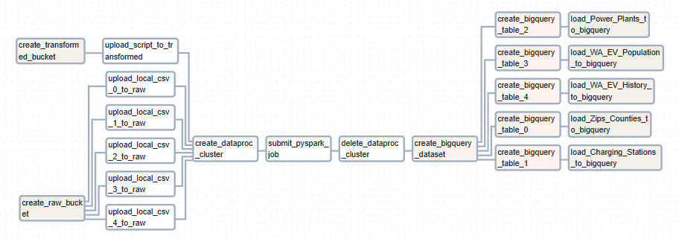

Airflow DAG workflow duration - 7 mins to construct storage buckets, process data and place into data warehouse.

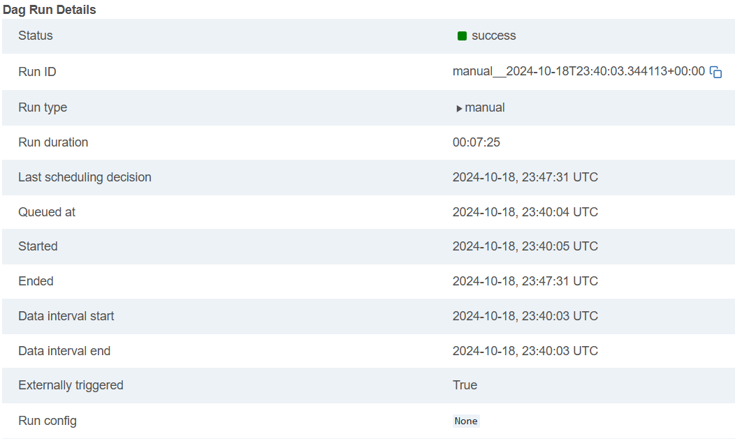

The following images display time elapsed (two minutes) and memory used, and miscellaneous resources of the Dataproc cluster used to process multiple datasets from this project.

